The Buettner Top Ten List of 09

10.
We all made it another year with no mishaps
9.
Ryan is experimenting with a new High School Staying with his Dad now in Sacramento
8.
The whole Fam Damily got together for the first time in more years than we care to remember
7.
Bob and Andrew are still hanging together and Bob got nominated for a People’s Choice Award for his online Radio Show (OOPs he lost to Harry Potter!!! – next year!!)
6.
Pam and Tonya both keep getting clean bills of health
5.
Jeremy moved back to California, got a job AND a Girlfriend.
4.
Along with the rest of her juggling acts Rachel is now marketing and selling a new skin care line and of coarse keeping an eye on Chloe, Claire and Julian
3.
All Five Grandkids meet for the first time AND they got along and even liked each other.
2.
I turned SIXTY?!?!?!?

And the No. 1 thing this past year
Amy and Jay got MARRIED!!!!!!!

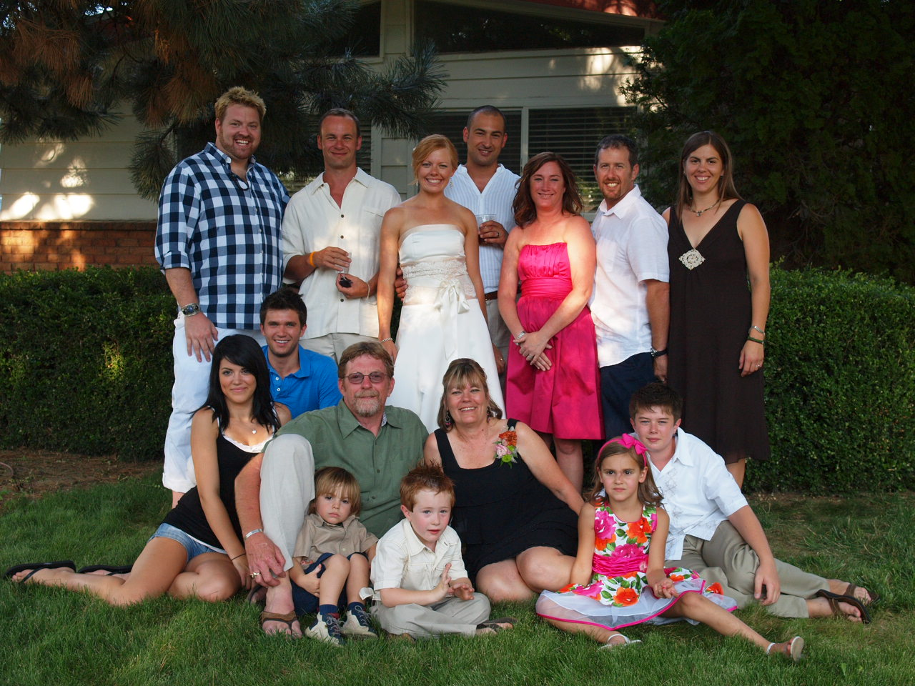
The Entire Clan
Top Row: Bob, Jeremy, Amy, Jay, Rachel
Next Row: Chloe, Andrew, Chuck, Pam, Ryan
Bottom: Julian, Jake, Claire

